
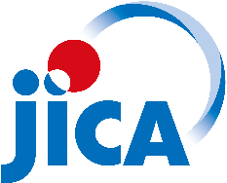


TCP-PIAT NEWSLETTER
  - Technical Cooperation Project for
  - Promotion of Irriagted Agriculture in Terai Plain

  - “Maximum use of water, Grow for sale”

No. 4 | June 2023
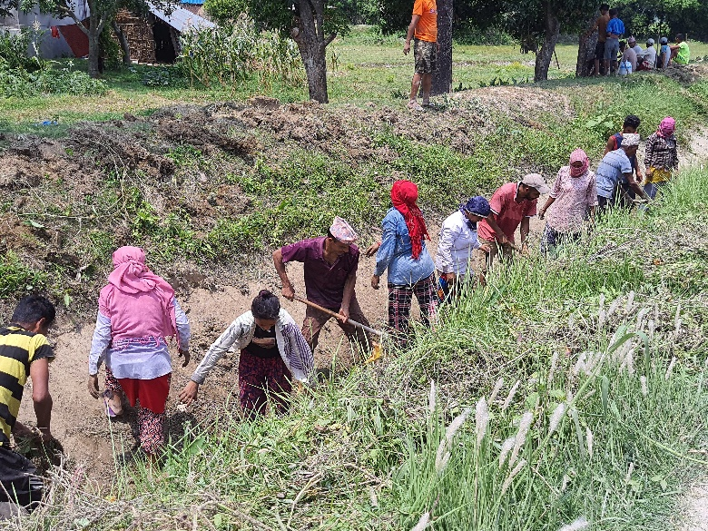 |  | 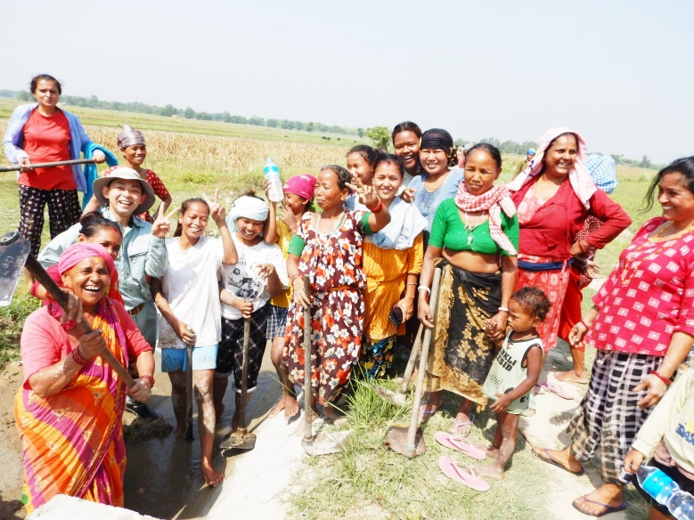
Canal cleaning work by water users of Secondary canal-17 at Gauradah-09. |  | A big smile of water user’s after completing the canal cleaning work at TC-4 of SC-7.
Canal Cleaning by Water Users
Recently, on the call of secondary committees of the Kankai Irrigation System, the users voluntarily completed the secondary/tertiary canal cleaning work. It was seen that the participation of both men and women in canal cleaning was encouraging. It seems that all the concerned parties especially the users committees are aware that there should not be any interruption in the uninterrupted supply of irrigation water for the main crop of Nepali farmers, paddy. Regular canal cleaning is essential to achieve targeted services by keeping the entire irrigation system intact. Since it is more beneficial to carry out maintenance works by preparing an action plan and implementation schedule, an annual action plan and implementation schedule is required for the maintenance of the canal system. It is necessary for the sustainability of the canal system and its structures that all the secondary/tertiary/DTOs committee of the water users organization prepare their own maintenance plans and prepare them and implement them accordingly.
Field Channel Construction
Field channels are necessary for proper and effective use of irrigation water. The utility of the field channel seems to be important for this situation in which the rear fields are unable to get water without soaking the upper field. As per the target of creating a total of 12 kilometres field channel from the user’s level in the TCP-PIAT project within the Kankai irrigation system, 8 secondary canal committees have started the work of constructing this field channel. Up to now secondary canal committee 1, 4,7,10,14,15,17 & 20 have constructed field channel total of 5 km. For this, Kankai Irrigation Management Office and WUA have provided necessary physical support as per requirement and project has supported to provide technical assistance as necessary.
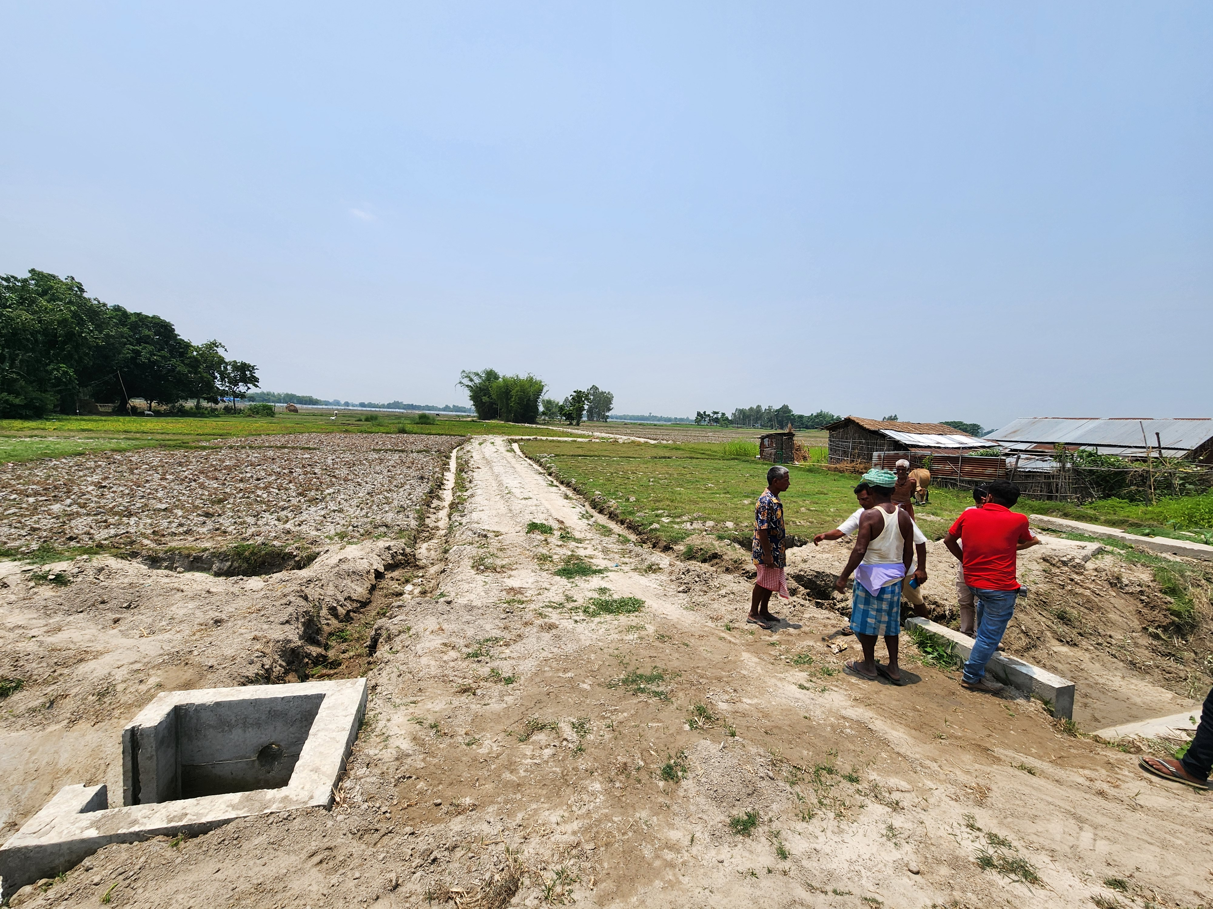

Field channel construction done by water users at TC-11 of Secondary canal-4.

On 21th June, 2023, the President of Kankai Canal Water Users Association and TCP-PIAT team jointly met with the heads of Gauradah, Sivastakshi , Kamal and Gauriganj municipality. There has been a positive assurance from the concerned authorities which would include the issues like conservation of irrigation facilities/canal structure, rational use of canal water and collection of irrigation service fee in the policy and programme of the municipality for next fiscal year .

Commercial Agriculture Promotion (CAP): For Sustainable Agriculture
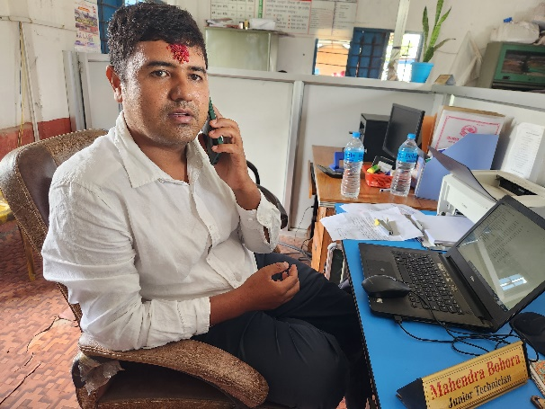
Mr. Mahendra Bohora, Junior Technician at Kamal Rural Municipality, has been working in the agriculture section for the past four years.
He has joined the government service since 2068 and has served as an agricultural technician in Panchthar, Taplejung and other districts and is currently serving in the local municipality. Regarding the question of what difference did you get while working in the municipality and the district, you feel that the municipality has more responsibility and accountability.
When inquiring about the use of technology by the farmers, it is felt that the adoption rate of the technology according to the need of the farmers is higher than the technology available from the government level.
Farmers tend to take agricultural services from the local Agrovet rather than the government level, because with Agrovet, the farmer is able to get the availability of agricultural materials, agricultural technical advice, at the same place and at the right time, but only receives technical advice from the municipality. Therefore, the attraction of farmers towards Agrovet is more. He said that the municipality has a large work area in terms of providing services and the availability of human resources, vehicles facility and budget for fuel is not enough to provide the expected service to the farmers.
According to him, the obstacles seen in the commercialization of agriculture include lack of proper availability of agricultural materials, lack of technical knowledge, lack of agricultural labourers, lack of knowledge related to marketing, farmers not being able to compete with Indian products etc.
He has been associated with the project for a long time and has actively participated in different activities related with TCP-PIAT activities. He has also participated in market survey in Damak vegetable market and observation tour of Mama Bhanja Agricultural Farm a commercial agriculture farm, of near Birtamod organized by TCP-PIAT . He said that he was also involved in activities such as potato purchase agreements produced by farmers with potato traders under market relations.
This principle adopted by TCP-PIAT is certainly useful. Agriculture cannot gain momentum by keeping agriculture separate from marketing. This principle is indispensable for sustainable agriculture.

Agriculture : A permanent and reliable occupation
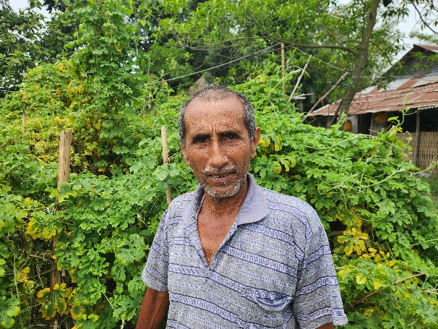
Mr. Surendra Raya, a farmer from Kamal Rural Municipality-1, is a commercial farmer. He has been commercially cultivating vegetables and producing cash and cereal crops for the past five to six years. He believes that the farmer's land is for agricultural production and keeping it fallow is not doing justice to the land itself. He is convinced that agriculture is a dignified profession and can meet all the needs of his family members.
In the last season, he cultivated mustard on 1.25 bighas (0.85 ha) of land and produced 1.2 tons of mustard, from which he managed to make a profit of about NPR 170000 by deducting expenses. Similarly, he cultivated spring rice on about 9 kattha (0.3 ha.) land, maize in 15 kattha (0.5 ha) and rainy season paddy in about 2.5 bighas (1.68 ha). He said that the market price of spring paddy this time is much better than last year. He also says that a small quantity of gourd, bitter gourd, and chilly have also given a good income. He said that due to the outbreak of special types of insects, about 200 plants have been completely destroyed this time, so he have not been able to earn income from cucumber farming. This kind of problem occurs sometimes in the agricultural profession, but the farmers should never be disturbed, they should be able to take it easy, he says.
In addition to farming, cow and goat rearing and quail farming can also be seen in the farm . There is a availability of necessary tools and machinery such as hand tractors to plough the fields, grain grinding machines to feed for animals, grass cutting machines. Goats like Boer, an improved breed can also be seen in the shed .
One plastic tunnel has been constructed with the help of Agriculture Knowledge Center and another one has been constructed at his own cost.
He has been in contact with TCP-PIAT for almost a year and has participated in various trainings and workshops. He says that he has gathered a lot of information by visiting Mama Bhanja agricultural farm, a private commercial agricultural farm. He commented that this visit organized by TCP-PIAT was fruitful as he has learned more about vegetable farming and marketing.
Talking about the problems faced in agriculture, he said that the problems of not getting the necessary agricultural materials, including quality seeds, not getting proper price for the produce, problems of marketing, lack of technology and agriculture technician are the main problems.
Despite some problems, agriculture is a permanent and sustainable profession, which he believes that all the needs of his family can be fulfilled by giving a commercial form and calls upon all the farmers to do the same.

Interview
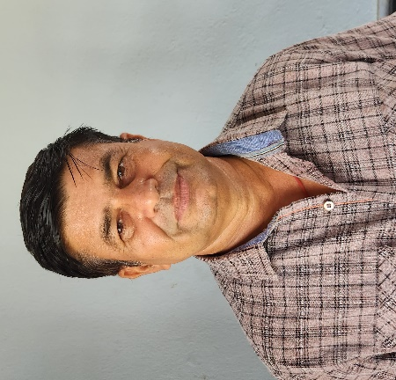
(The statement based on interview given to TCP-PIAT Newsletter from Mr. Kamal Bhandari , the newly elected President of Kankai Canal Water Users' Association Main Committee, about the organization's future programs and plans)
- What is the plan to ensure equitable water distribution in the entire Kankai irrigation system?
All possible efforts will be made to keep the canal structures of all secondary/tertiary/DTOs fit. For this, all the secondary/tertiary/DTOs committees will be fully mobilized. Every effort will be made to raise necessary resources for the maintenance of the structures. The available resources will be properly utilized in coordination with Kankai irrigation Management Office.WUA committees will be careful not to allow gate keepers to release water more than as specified in parcel flumes and not to put pressure from users.Users will be encouraged to make a cultivation plan according to the crop calendar by bringing diversity in the cropping system.

- The target of constructing a 12 km field channel has been set during the project period, what are the challenges of achieving this goal and how likely do you see that this target can be achieved?
The field channel is an essential structure for the proper and effective use of irrigation water. The utility of the field channel is clearly visible for this situation in which the lower field cannot get water without soaking the upper field. It has to be built by the water users at their own expense. We are confident that the target of creating a 12 km field channel called by TCP-PIAT can be completed throughout the project period. Eight secondary committees have already started the construction of field channels despite some hurdles such as the fear of land acquisition among the land owners, the fear of spoiling the nature of the land, some social and political differences among the land owners, the absence of the concerned land owners, the inadequacy of some construction materials. So far, 5 km field channel has been constructed and the remaining 7 km will be completed by coming winter.
For this, I would like to inform you that the Main Canal Committee is supporting the construction of the field channel by providing necessary coordinating role and resources.

- What are the strategies for improving irrigation service fees?
Ensuring equitable water distribution in the Kankai Irrigation System is a prerequisite. As soon as this is ensured, the current problem of irrigation fee collection will be solved to a great extent.
An effort has been initiated to prepare land owner list of KIS area as per secondary/tertiary canal -wise with the help of TCP-PIAT . All secondary/tertiary committees have been mobilized to update the data to prepare master list of KIS area .The data will be updated by mobilizing special manpower to acquire data in the SC/TC where it is necessary .
The available details are further processed and uploaded to software being prepared by KIMO for WUA , to make it convenient to manage the data of land owner list and ISF management.
Since irrigation service fee is the main source of WUA for maintenance of canal and office overhead and MCC will organize training, workshop to make aware the users to understand their responsibility to pay ISF.
In order to discourage the tendency of some users not paying the ISF as per the rules after using the irrigation water, the main committee will take steps such as publishing the names of the fee payers in the newspaper, requesting the local government for action, stopping the irrigation facility etc.
All LGs have included the issues to support in ISF collection in their policy and program for FY 2081/82 and it is expected that the ISF collection will be improved.
- What are the issues/problems in the maintenance of irrigation structures and how can they be resolved?
Since the structures of Kankai irrigation system are very old and dilapidated, it is necessary to restore and rebuild these structures.Due to no provision of division box in the field channels, there is a problem in water distribution.
The bank of tertiary canals are old and worn out and the concerned body should reconstruct it.Since the organization's resources are not able to carry out the mentioned works, the concerned authority should make an action plan in this regard and carry out those works.

- What is the strategy to run the proposed Agricultural Machinery Service Center (Custom Hiring Center) in the organization in a sustainable manner?
Agricultural mechanization plays an important role in increasing the production and productivity of agriculture. For the convenience of users/farmers of Kankai Irrigation System, arrangements have been made to provide some agricultural machinery under the main committee on rent at a reasonable charge as per the demand of the users. At present, agricultural machinery like paddy, maize mobile dryers, multi-threshers, land leveler, tractor, zero tiller machine, excavators are available in the organization. As far as resources are available, other necessary machinery will be added and made available to the user on rent. The agriculture mechanical sub-committee in the main committee will be made responsible for the systematic mobilization of agricultural machinery. An effective operational guideline is under preparation and it will be implemented after approval from the General assembly. The Committee shall be careful not to allow unwanted use or misuse of agricultural machinery by any party. The rental price of the machinery will be fixed after proper evaluation of the market price of fuel and accessories, repair and maintenance cost of machinery and other administrative expenses.

- How can Water Users Association help farmers through Commercial Agriculture Promotion (CAP) to increase the income of farmers of Kankai irrigation system?
Commercial agriculture promotion is the need of the day. All farmers must adopt the motto of “Grow for Sale” combining agriculture with marketing . Activities such as taking initiatives for supply of agricultural materials to users /farmers and farmer groups, lobbying for facilities available from local and government bodies, requesting the concerned agencies to conduct training and seminars on modern agricultural technology, collaborating with organized organizations, individuals and companies for the marketing of agricultural produce can be done.

TCP-PIAT Activities in pictures
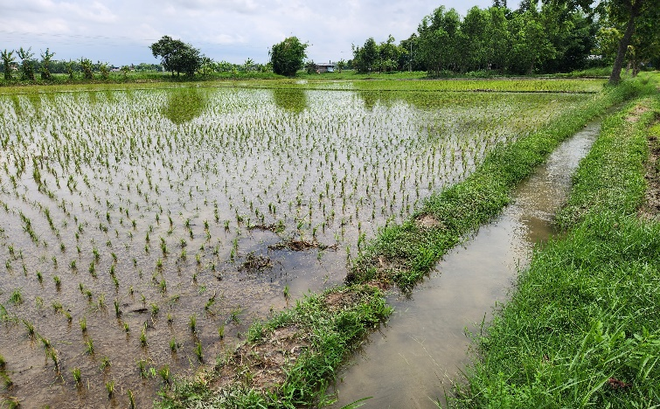 | 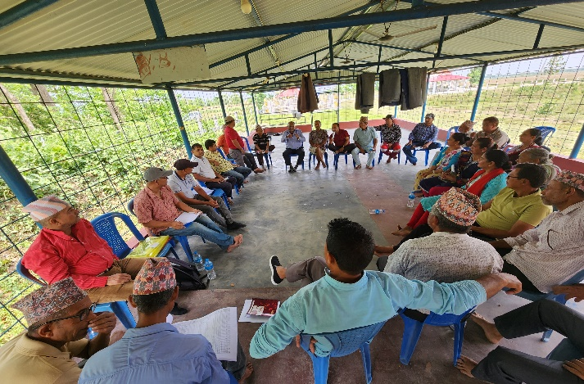
Irrigating the paddy field through Field channel prepared by water users at TC-04 of SC-14 | A training on Master list (Land owner list) updating at SCC-0 at Shivasatakshi-10
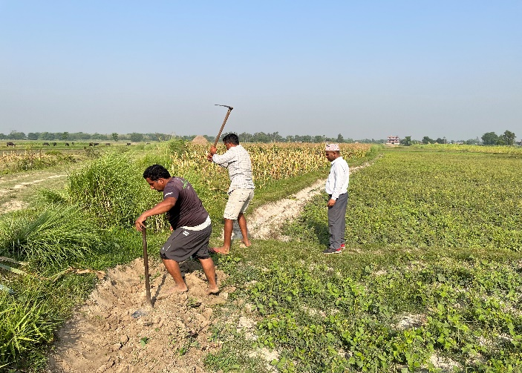 | 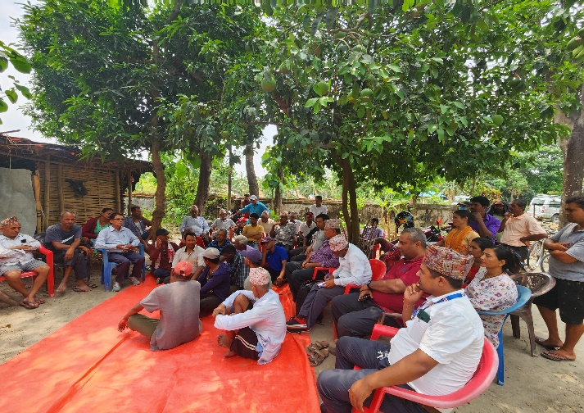
Chairman and secretary of SCC-07 actively participating in field channel construction which is responsibility of water users. | An interaction with farmers/water users, LG, TCP-PIAT and NKC on Ramdhan rice promotion at SC-14.
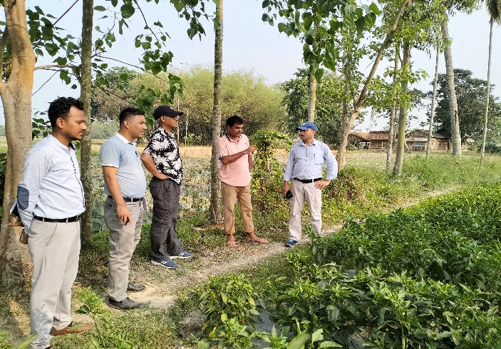 | 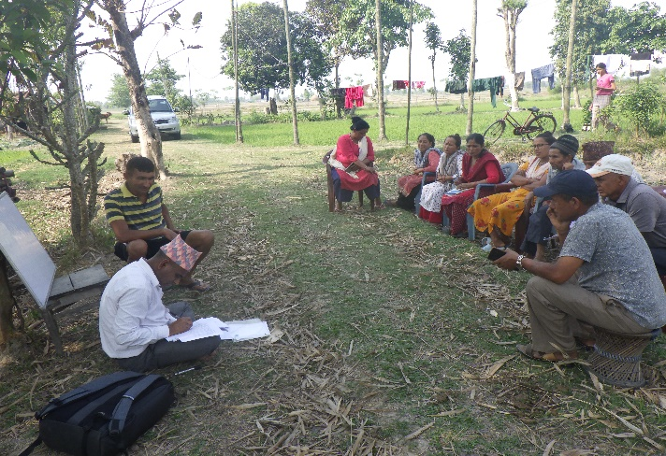
Mr. Sushil Koirala, Joint Secretary of MoEWRI , the chairperson of JCC of TCP-PIAT project interacting with farmer at TC-06 of SC-01 | On-site coaching, an activity of TCP-PIAT to disseminate farming technology at their field of farmers (SCC-15).
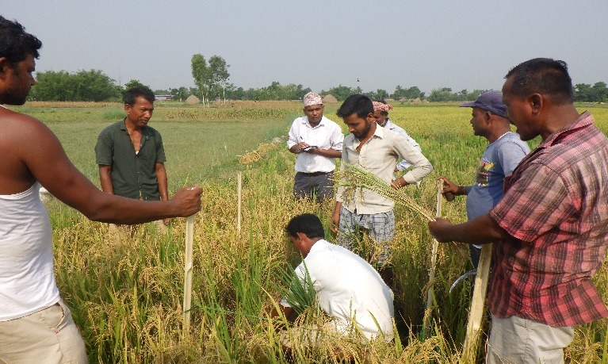 | 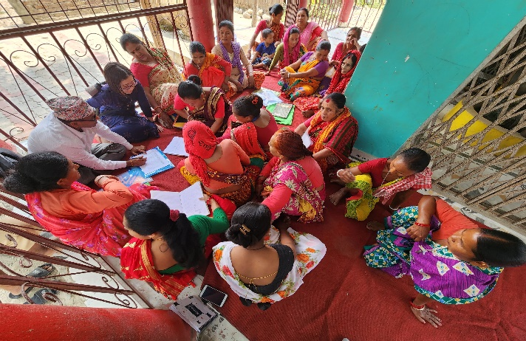
Crop cut survey at SC-04 on spring paddy at land levelled plot (Shivasatakshi-4). | Women farmer group (SC-07) presenting their profitability record maintained for winter vegetable crop.

